Lab 6
OBJECTIVES:
- To learn and understand the working of different types of decoders
- To learn and understand how to design a multiple output combinational circuit using Decoders

EQUIPMENT: Logic trainer, Logic probe

COMPONENTS: ICs 74LS08, 74LS32, 74LS04, 74LS139

2-to-4 line decoders:
74LS139 IC contains two fully independent 2-to-4 line decoders with active low enables. The function table and connection diagram for this IC are shown below:
Function Table:
Enable | Selection Inputs |  | Outputs
G | B | A | Y0 | Y1 | Y2 | Y3
H | X | X | H | H | H | H
L | L | L | L | H | H | H
L | L | H | H | L | H | H
L | H | L | H | H | L | H
L | H | H | H | H | H | L

H= Logic High, L= Logic Low, X= Don’t Care
Connection Diagram:

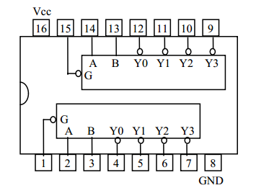

3-to-8 line decoders:
74LS138 IC contains 3-to-8 line decoder. The function table and connection diagram for this IC are shown below:
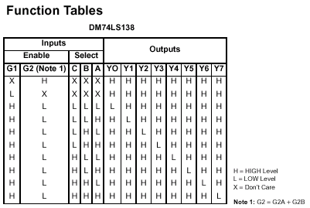
Connection Diagram:

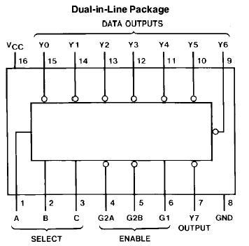

Lab Tasks:
Question 1 (Hardware Implementation):
Make a truth table and implement on Logic Works first 2 to 4 Decoder with a low enable using 8 AND gates and 3 NOT gates.
Question 2 (Hardware Implementation):
Implement on Logic Works first 3 to 8 decoder using two 2 to 4 decoders and a NOT gate
Question 3:
Implement on Logic Works a doubler circuit. It takes a 3 bit input and multiplies it by two and gives a 4 bit output using decoders and other logic gates.

